Volunteer
Information
Pack

2024

Volunteering / Placement Role Description

Volunteering / Placement Job Title: English Teacher / Tutor
Organisation Type: ALPHARD EDUCATIONAL CENTRE – ENGLISH IS FUN...TASTIC!!! SUMMER CAMPS 2024 - ROMANIA
Location of placement: PIATRA NEAMT CITY or SUCEVA CITY, RO
Supervisor Name: Prof. ANDREEA TABARNAC
About the Organisation:
My name is Andreea Tabarnac and I'm the Educational Coordinator of two English Summer Camps in Romania.
For more than 13 years we have enjoyed a wonderful collaboration with Universities from the UK with many students from Leeds Beckett University. We have received almost 400 students to date from a range of countries and universities including Leeds, Manchester, London, Birmingham, plus other countries including Italy, Germany, Greece, Ukraine, Spain, Portugal, and Turkey.
Every summer we invite 40-50 students to work with us as teachers, tutors, or trainers for an alternative placement requirement or to gain more experience in working with children and teens who speak English as a second language. We pay for your return flight, airport transfer, food and accommodation plus social excursions during free-time. You would need minimal spending money.
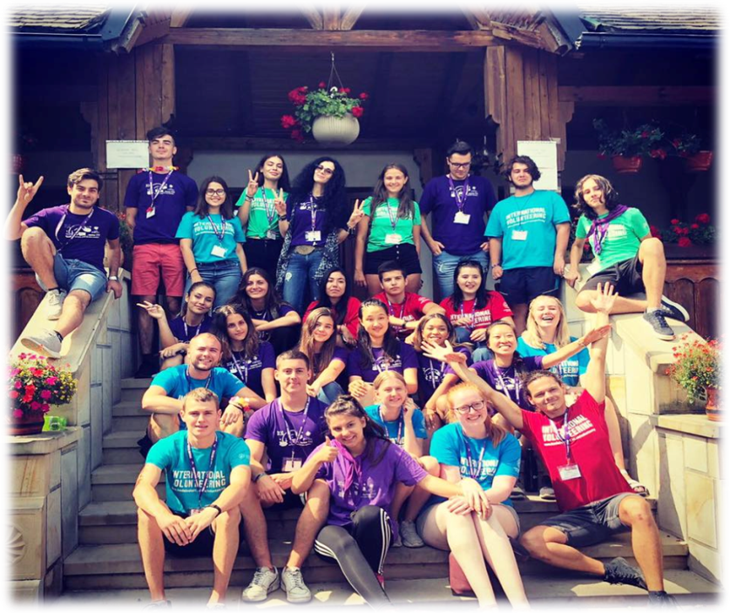
The work involves teaching English to children aged between 6 to 18 years old who cannot afford trips abroad, so we bring the “abroad” to them. This year’s summer camp will begin on 15th June and end 1st September 2024. We are looking for volunteers who can complete a minimum of 3 weeks volunteer work, up to a maximum of 12 weeks.

Where are the camps?
- The first camp is situated in the heart of Romania in a beautiful mountain city – Tarcau, Neamt. The camp will be at Maierus Campus Tarcau.
- The second camp is a 90 minute drive from the first camp, in a very beautiful region called Bucovina (Voronet, Suceava City). The camp will be at Casa Elena Voronet.
- You can see our camp photos accessing our Instagram of Facebook page.
Volunteer testimonials
Many of our volunteers return repeatedly as they enjoy their time so much. You can read Testimonials, we can put you into contact with previous volunteers who will be happy to discuss their experiences and you can also meet some of them at our information sessions which will be held in Leeds in March 2024.
- We have hundreds of happy children willing and eager to meet the new volunteers – teachers, trainers, mentors, tutors …

- We have 40 Romanian students each week (our staff) ready to help and assist the international volunteers.
What can we offer? This is an all-expenses paid trip in return for your time!
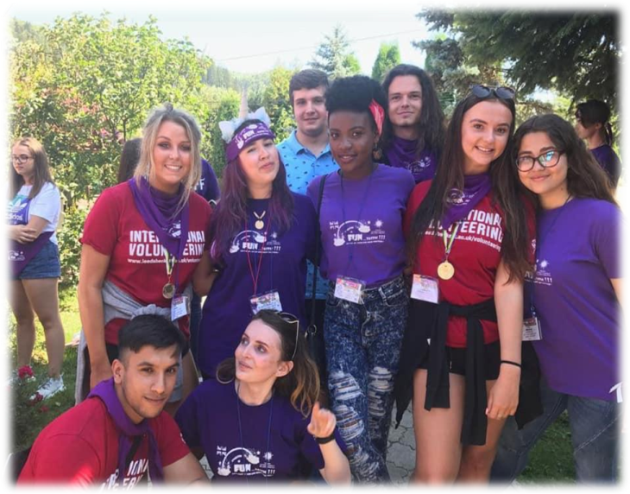
- Free return flights from the UK to Romania (airports London/Manchester/Liverpool) and free return transportation from Bucharest airport to camp.
- Accommodation in a large house shared with other volunteers near the camp, three meals a day at the camp’s restaurant and other treats.
- The opportunity to be an English teacher, a tutor, a mentor, a learning facilitator, a trainer, or a supervisor for a few weeks.
- The opportunity to travel and meet people with a different culture, different ideas, food, and beliefs.
- The opportunity to meet wonderfully talented children eager to learn or speak English.
- Lots of excursions and trips for fun social activities in your free time. Please see the camp schedule below for examples.
Summary of Placement:
Our Voluntary Work Placement programmes are typically 3 - 12 weeks and provide students / groups or students with an opportunity to gain teaching experience, improve management skills and enhance life skills through this experience, living with international students and attending social and cultural events and activities. Our organization organizes and pays for the flights (flights within the European the borders, including the UK), the airport transfers from/to Bucharest to/from the camp, three meals a day and accommodation with the other students involved in the programme and trips (see the schedule of the camp), free training to support you in your volunteer role, plus support during all the activities held in the camp … and a lot of fun.
The voluntary work placements can be for the full duration up to 12 weeks on request, or for a minimum of 3 weeks (and any other duration that you wish). The application process is very simple and free of charge. Once successful, we ask for a fully refundable deposit of £100 to secure your place This allows us to organize and pay for your flights and you will receive a full reimbursement upon completion of your volunteering.
To apply, please complete the application form and a send a copy of your passport to andreeasclub@yahoo.com . The passport is so we can confirm you have sufficient expiry for travelling and so that we can book your flights for you using your correct personal details.
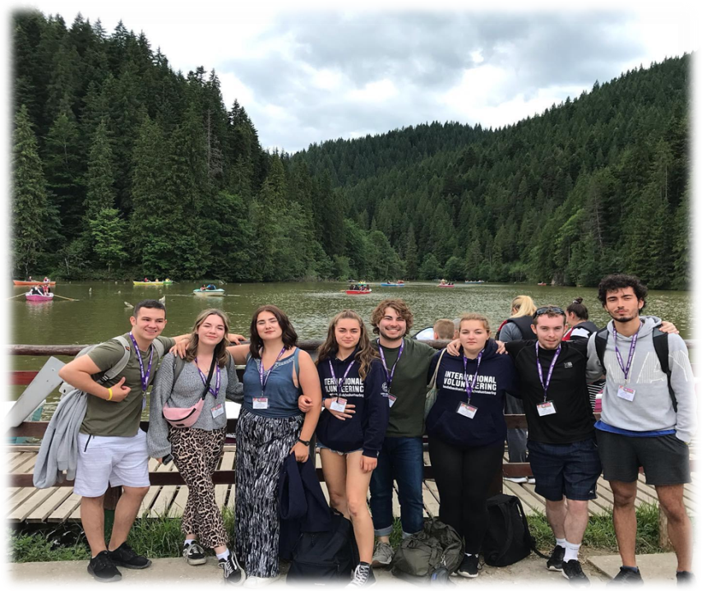
Camp schedule (summary)
This is a typical schedule summary of the camp activities: First, we will offer the transportation from Bucharest to the camp, full accommodation and three meals a day in a hotel in the camp or in house near the camp:
This year the camp starts on 15thof June and ends on the 1st of September 2024.
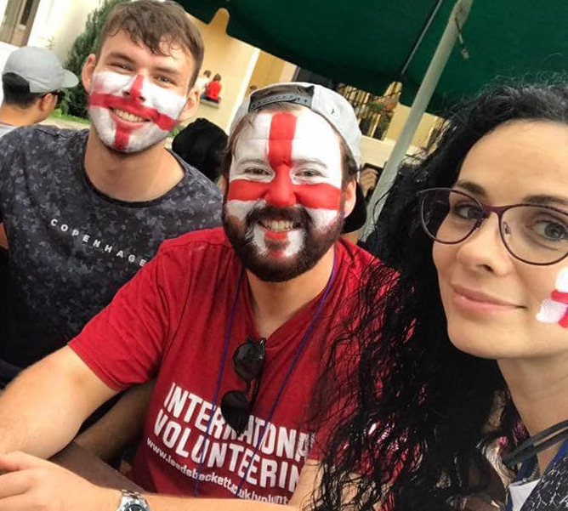
Every week, starting on Monday evening till Sunday morning, we'll have different groups of children aged between 6 to18.
Monday: we have English classes from 7.30 pm to 8.30 pm where we meet our young students and make plans for the week (on Monday morning and afternoon, the volunteers are free to relax or to make plans, watch TV, etc...).
Tuesday: we have an English class (games, stories, learning new words or speaking) from 10.30am to 11.30am, then a coffee break, then another class from 12.00 till 1.00pm. In the afternoon for 2h hours (4.00pm – 6.30pm), we'll play with the children all kind of games and sports. Later, we have disco and disco contests.
Wednesday: we have classes (as we had on Tuesday) and in the afternoon we have a trip to AQUA PARK where we have water games (on Wednesdays the volunteers can have a free afternoon if they want to visit the city or go shopping). In the evening, we have disco and disco contests.
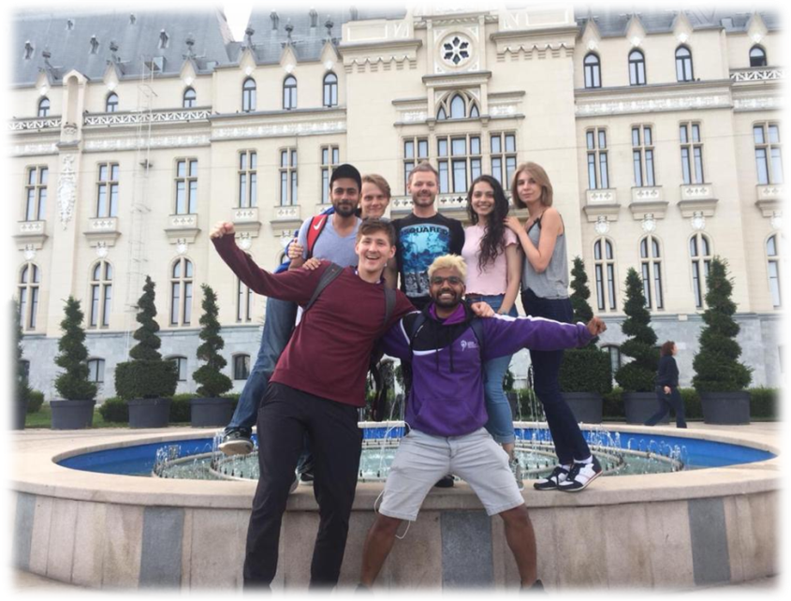
Thursday: we have 2 English classes in the morning and in the afternoon, we have another trip where we'll go hiking, boat sailing and we'll discover Romanian stories and legends. In the evening, we have disco and disco contests.
Friday: we have 2 English classes in the morning and in the afternoon, we have the third trip: we go by cable car on a mountain where we'll play paintball. (The volunteers can have a free afternoon). In the evening, we have disco and disco contests.
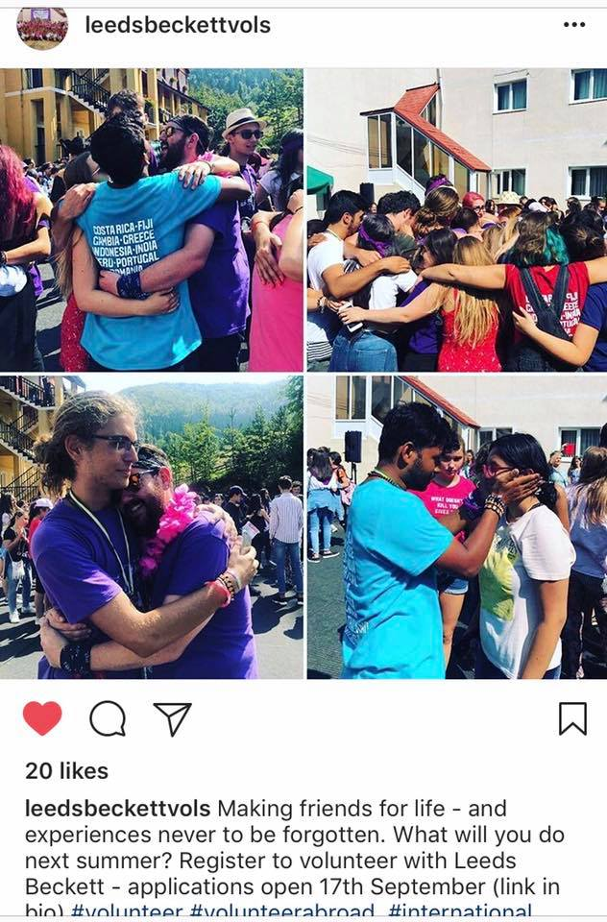
Saturday: we have 2 English classes in the morning and in the afternoon (4.00 - 6.30pm) we have painting classes, face painting, origami, and all kind of funny activities for children. In the evening, we have disco, disco contests, and the campfire.
Sunday morning: we'll offer diplomas, medals and presents to the children and say goodbye to them. On Sunday afternoon we always have a new experience - we have a barbecue with all the staff members, we go to see a movie, or we go shopping at the mall, we go sailing or off-roading, we go to spa or to the swimming pool and other funny things.
Each evening: we'll have disco parties and all kind of contests for children (from 8.00 pm to 10.00pm).
Duties to Include:
The students will be tutors, trainers, teachers and will run fun English classes for children and teens (through games, sports, art, journalism according to students ages). All the support, training and materials are provided. The non-Romanian speaker will always have one or two Romanian assistants.
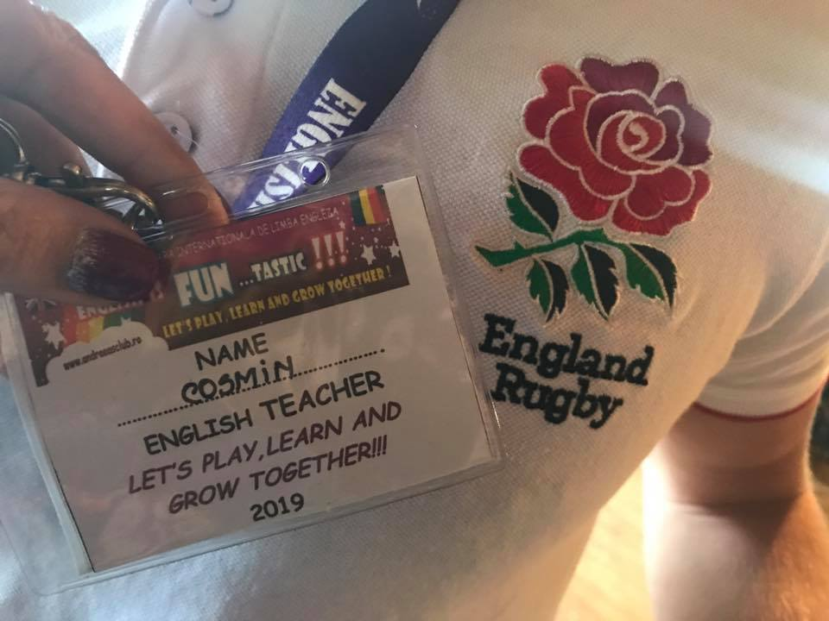
Person specification
Essential:
- Good interpersonal social and communication skills
- Time management and organization skills
- Confidence & Assertiveness
- Initiative & leadership
- Team working skills
- Professional Attitude
- Empathy
- Flexibility

Travel and accommodation:
Our organization provides the return flight* the transfers from/to Bucharest to/from the camp, three meals a day and, accommodation with the other students involved in the program and trips (see the schedule of the camp), free training for this placement and support during all the activities held in the camp.
*Return flight from London / Liverpool / Manchester or other European Capitals (depending on the costs) to Bucharest (and return) and transportation from Bucharest to / from the airport.
FURTHER INFORMATION AND HOW TO APPLY
For further information and to apply please visit our website or complete the application form and return to andreeasclub@yahoo.com.
We will be hosting Volunteer Information sessions at Leeds Trinity University and Leeds Beckett University between 11th and 14th of March 2024 at both campuses (online and in person). Please contact us if you would like us to attend a session.
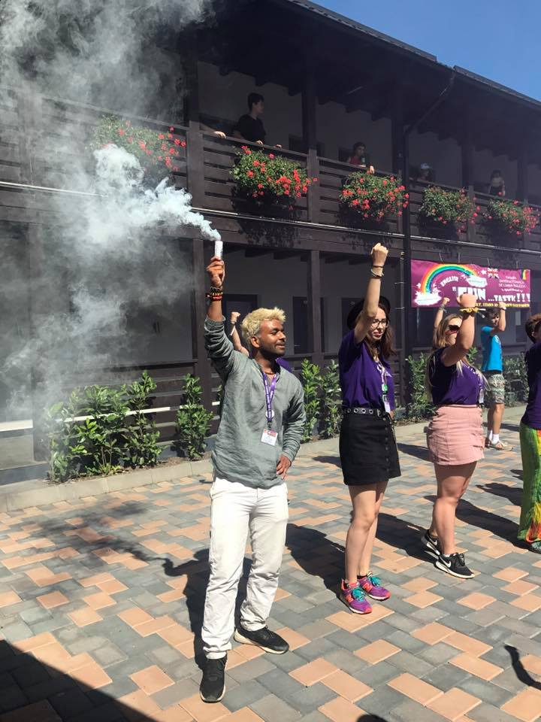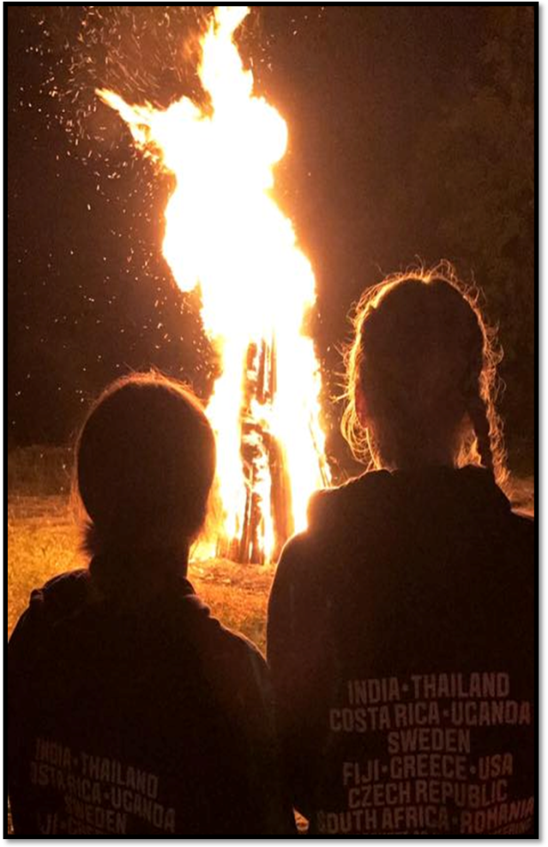

“The best way to find yourself is to lose yourself in the service of others.” Mahatma Gandhi

APPLICATION FORM

International Volunteering Supporting Information

ENGLISH IS FUN…TASTIC!!! 2024 SUMMER CAMP
Your full name
Course of Study
Year of Study
Student Email Address
Date available including preferred departure date
Number of weeks available and dates
3 – 12 weeks between 15th June – 1st September 2023
Copy of Passport  Please attach a copy of your passport with this document | This is to verify you have sufficient months to travel, and to also allow us to book your flights using correct name and passport number. It will be kept confidentially and destroyed once we have booked your flights.

Skills, qualities & experiences
We’d like to know a little bit about you and your previous experiences (a few lines). Please, read through and answer the questions below and try to call upon personal examples to demonstrate your answer. These examples could come from your: University life, work life, social life or anything else that you think would be appropriate. This should include at least one example per statement.
- Based on what you know about the project, what specific skills do you bring to the project?
- What do you hope to gain from the experience?
- What does cultural awareness mean to you?
- Can you please provide an example where you have demonstrated resilience?
- Can you please provide an example where you have demonstrated adaptability?

Once completed:
- Save the application form
- Scan a copy of your passport
- Email both the application form and your passport to
andreeasclub@yahoo.com

Subject title: Romania English Camp Application

